Roll Care

By Craig Brougher

A little knowledge about player rolls is sometimes nice to have when you want to protect an antique and valuable resource. This article is about how to take care of them, what to look for, and simple repairs. We’ll use a Duo-Art as our example, but this applies to any roll player piano format.

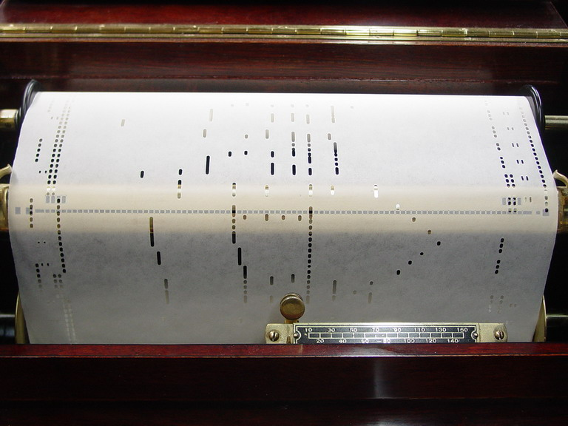
New rolls (ref. written in March, 2007) are safe, good rolls. Some are new arrangements, and some are reproductions of old arrangements, but at present, the holes are the correct size, the paper is high quality, the boxes are very nice, and they are just a wonderful buy. I suggest getting the new ones as they are offered, because once they are sold, they are gone. Restored players cost a lot of money and it’s a waste of money unless that instrument is played. 40-50 rolls is no collection. Think of how many rolls one would need to get their money’s worth, over a lifetime with the piano. In the teens and 20’s, most owners used to buy on average a new roll a week.

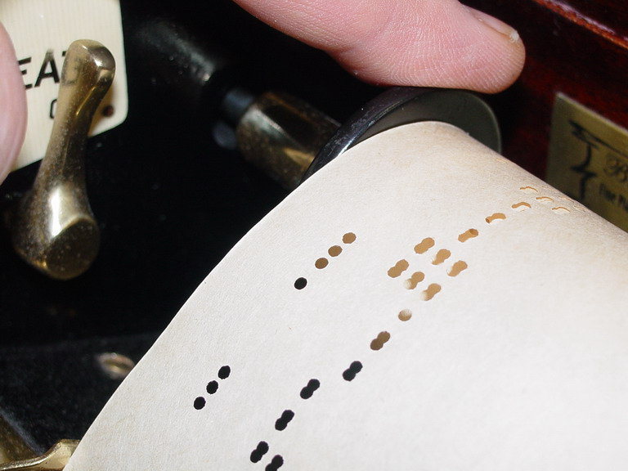
Old rolls are valuable, as most of these will never be recut again. So it’s important to protect them as well as you can. Paper becomes very brittle over time, even though it may not look brittle. Rolls have been wound around a cardboard spool at varying tension throughout their length and are seldom straight any more. This is why they wander back and forth, left and right as they pay out across the trackerbar (that brass bar with the holes in it). All reproducing pianos and most players have some kind of roll tracking system to compensate for that wander, but even if the roll plays well, it should be tended as it rerolls, since the tracking system gets turned off and the roll can rip on reroll.

An old roll is easily tended by stopping its rotation, just as soon as it begins to crowd one flange or the other. This is done by placing a finger on one or both flanges and simply pressing like a brake to stop air motor rotation momentarily. That relieves the tension completely and the paper is able to fall between the flanges as soon as the roll stops. The takeup spool can’t stop as soon and so it allows the paper to “jump” a little and takes out all the tension. By touching the flange like this, the roll will not tear up.
The left flange (shown) is loose. If it slips in the roll core, it should be tightened by building up with tape. The reason this flange is loose is to permit the roll paper to wander without tearing up. You can also pull it out a little, giving the paper more room, but only if it stays where you pulled it out. If not, add more tape.

A roll lasts as long as its box. As soon as the box gets broken, fix it or repair it. Elmer’s glue in the corners works perfectly. If the label needs replacing, do that, otherwise you nor anyone else will know what is in that box. If the tab gets torn off the roll leader, you can buy replacements from Player Piano Co of Wichita, Kansas or other suppliers. If the roll leader starts to tear, tape it immediately. Keep tape for roll repairs in your piano bench, along with a small can of talcum powder, in a box with your other supplies. Talcum each repair very lightly. Just a little on the tip of your finger works well. It prevents adhesive bleed out around the tape, years later. Some people use archival document repair tape. I personally use Scotch Matte finish “Magic Tape.” I have repairs dating back 40 years with the stuff. It’s just fine.

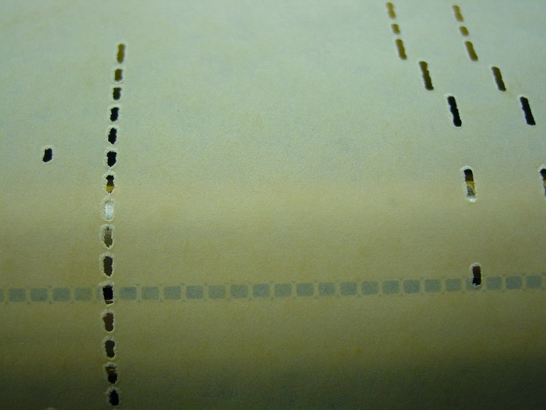
New rolls are less trouble as a rule, although you will probably own some newer recuts that don’t play right. For instance, I have a few recently cut rolls that don’t work well, at all. Notice that this particular song roll, on colored paper has a ragged, small hole, and since the edges are not trimmed correctly with the note holes, this roll runs to the right on a correctly tracked Duo-Art Player. Examine the shadow of the trackerbar holes behind the paper. Such a roll will play loud notes ok, but not very soft notes because the quantity of air required by the valve at very low vacuum is not sufficient in some models to lift the valve quickly. Another problem with small holes like these is that the chain bridging between the holes becomes wide enough to cut that note off and on as the bridging crosses the hole, creating a machine-gun like effect, rather than simply holding the note on. This roll does that. It is unplayable and defective, although a recent product. A roll manufacturer wants you to send all defective rolls back to them, otherwise they would not know about the problem.

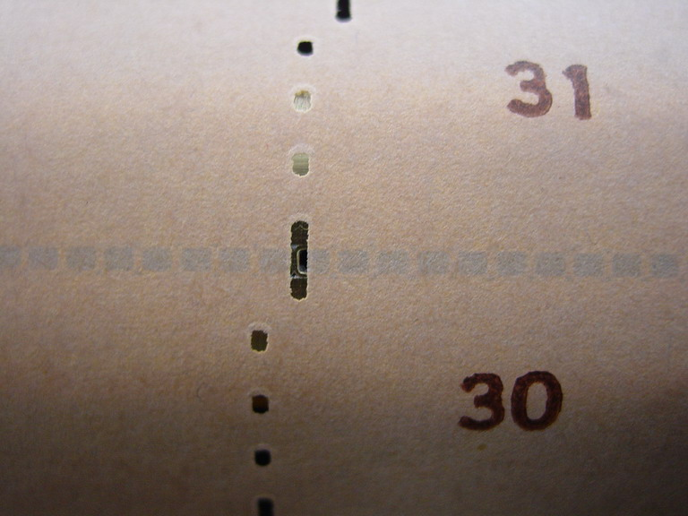
Here is a picture of holes in a Test Roll that is likewise unusable. The roll “tests” a Duo-Art, for sure. In the first place, it is a narrow roll. So if the piano were adjusted to its width, that piano would not play any other roll I know of since it mistracks so badly that as you can see, the hole in the paper is splitting two holes in the trackerbar. Next, the holes are far too narrow to test a good Duo-Art for soft play. So if you’re under this grand adjusting things and nothing seems to work, change test rolls. By the way, even the numbers of the notes played in this roll are wrong, being misaligned to the holes. This problem is not limited to test rolls. Fortunately, only reproducers are affected by smaller holes this way. Roll suppliers who specialize in reproducing rolls recently know better than this, and are very careful to give you a perfect roll.
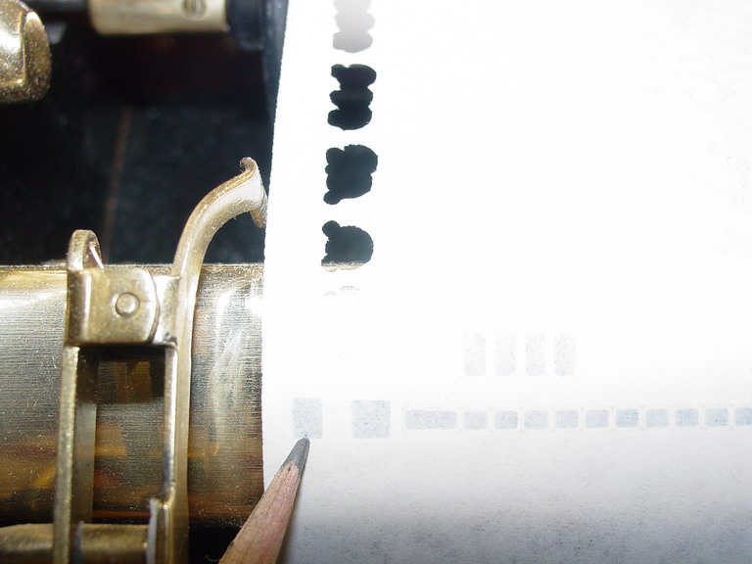
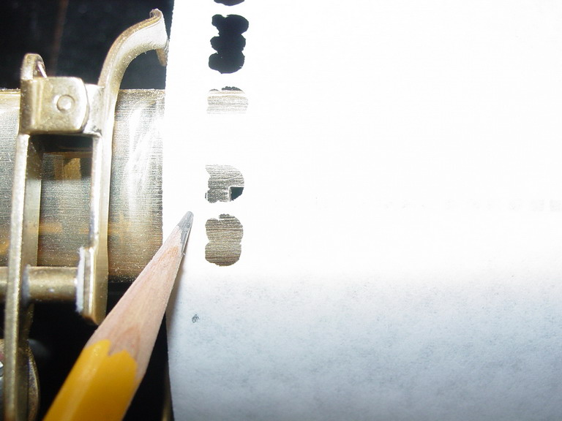
An other problem with some newer recuts of past years could be that certain holes like themes or even reroll (see pencil) don’t line up with the trackerbar, even though the notes played. That is not unusual, and if one of these rolls keep running until they rip off the roll core, there’s no harm done. Use a ticket hand punch and make sure the reroll hole works—not like the one shown here. Tape the roll back on the core, and rewind it.

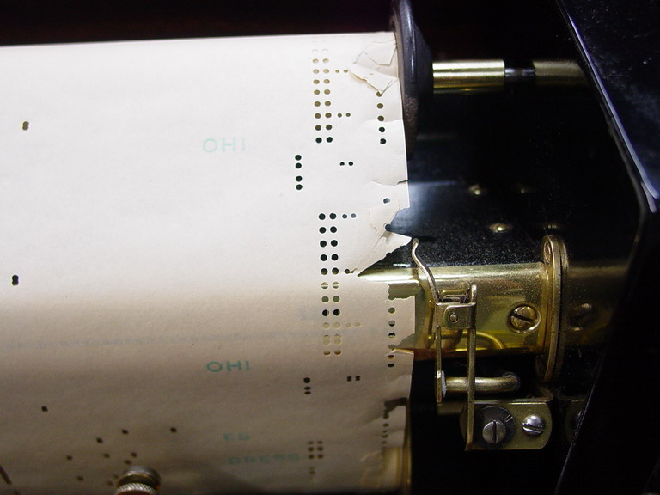
You will quite often run into an old roll that is pretty badly torn, as in the photo here. That is no reason to trash it. The best rolls of all are the torn ones. That’s because they were the last ones still played on the old unrestored player piano that didn’t track rolls well and damaged them. They might look totaled but they are very fixable. Don’t despair or give up quite yet. Here is an example of a roll that will take about a half an hour to fix. Use frosty tape, but never at full width as it comes to you on a dispenser. I gently lay a 3” length of tape on something that I can peel it off of, and trim it with a razor to about 1/8” strips, but sometimes 1/16”. From there I lift short pieces of it with my blade as a “holder” to position it. Make sure that each little flap fold is flat and straight. Tape large tears by starting with short, temporary “stitches” of tape. You can check and if you didn’t get it flat the first time, take it off and reposition it (as long as you stick it down lightly). Here you can also see the “feathered edge.” That prevents the roll from tracking, too, so using very thin strips of your tape, stick those back together. Then talcum them, too. For large rips it’s necessary to make the repair on a table or large surface.

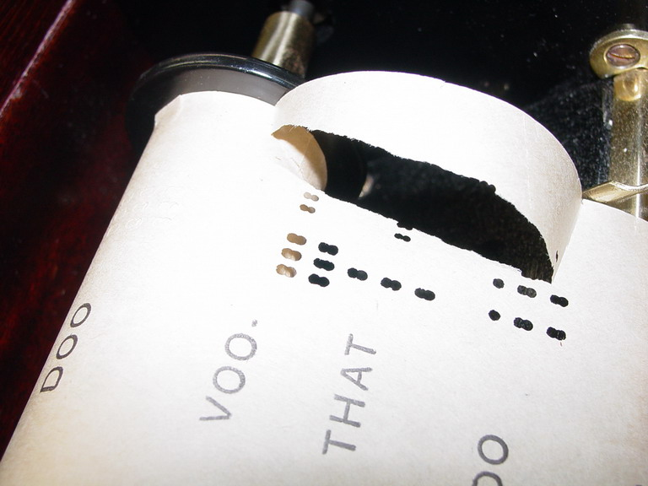
Here’s how I stitched a small rip with a tiny piece of tape trimmed from a section of dispenser tape. Here’s the rip. Next, the tape. Then we snip just a bit and tweeze it on. That took about a minute. By doing that, I saved my roll. The problem was not the piano but really brittle paper that was already split.
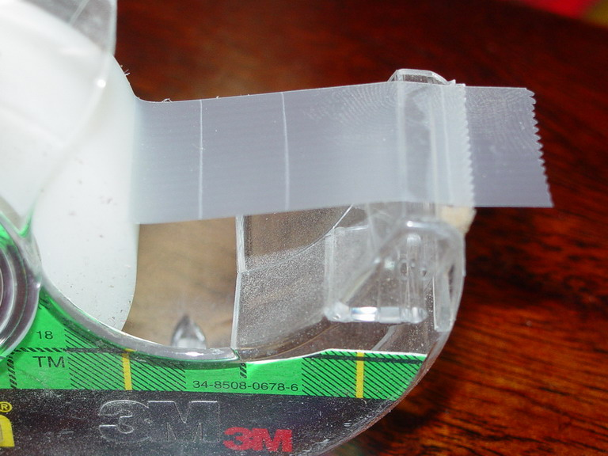
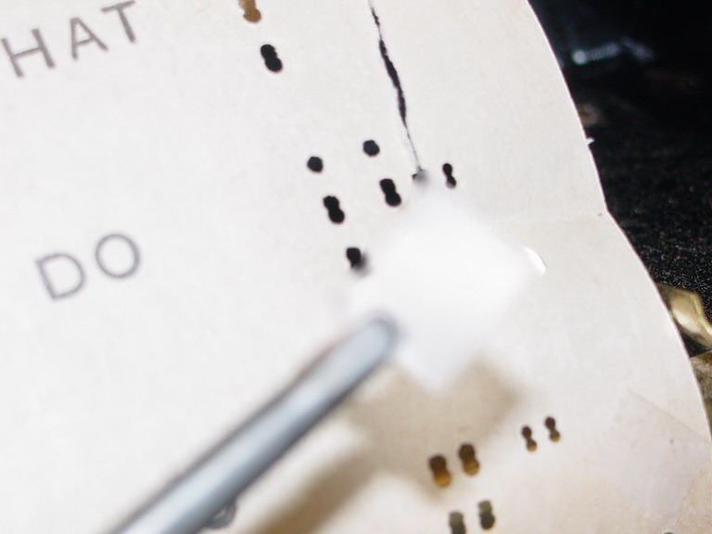

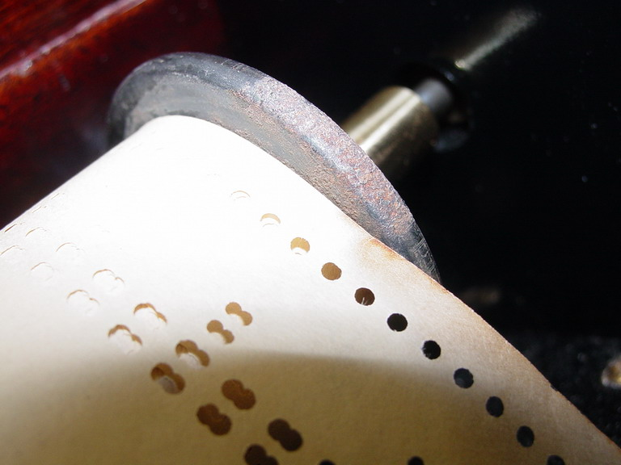
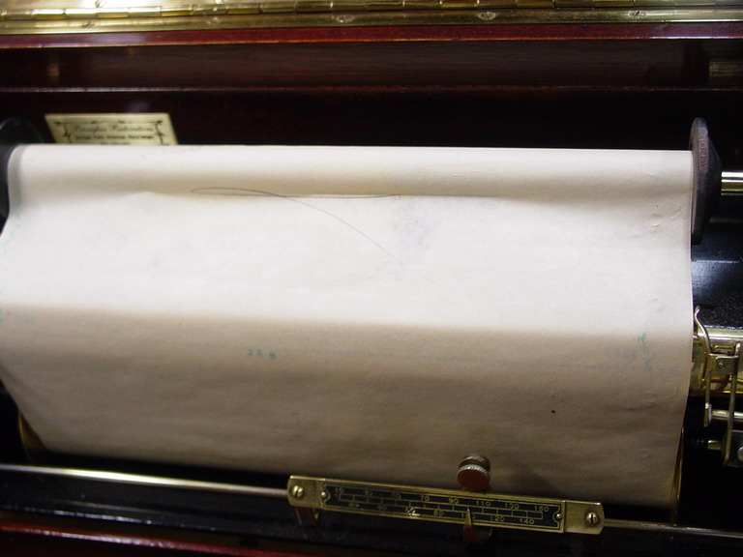
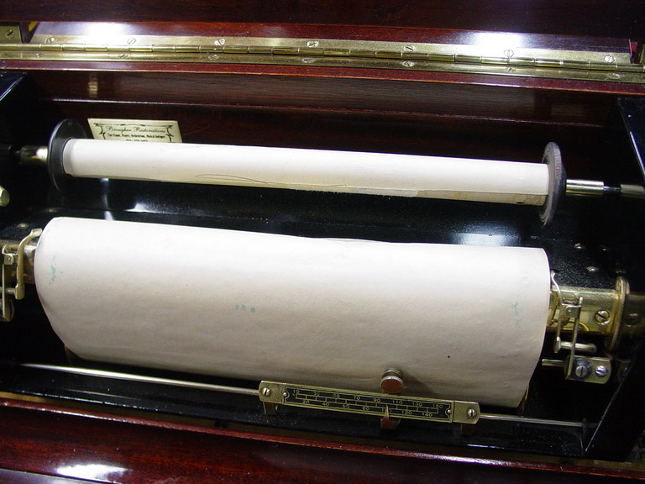
Rolls with metal flanges tend to tear up badly because the flanges sometimes gets rusty. The rust then tears the paper as it goes by. Here’s how to paint the right flange:
First, you spot a rusty flange.

Run roll past reroll perforations
Slice off the roll paper, remove
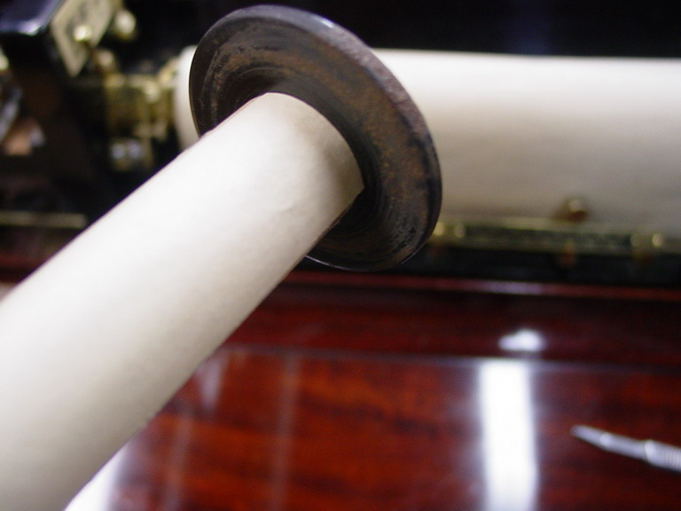
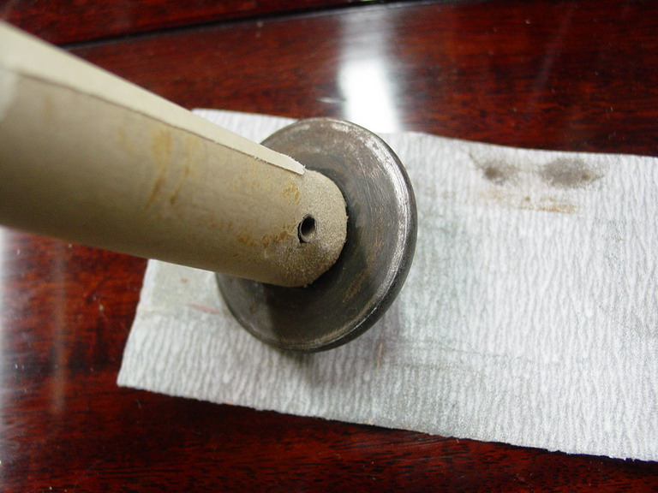
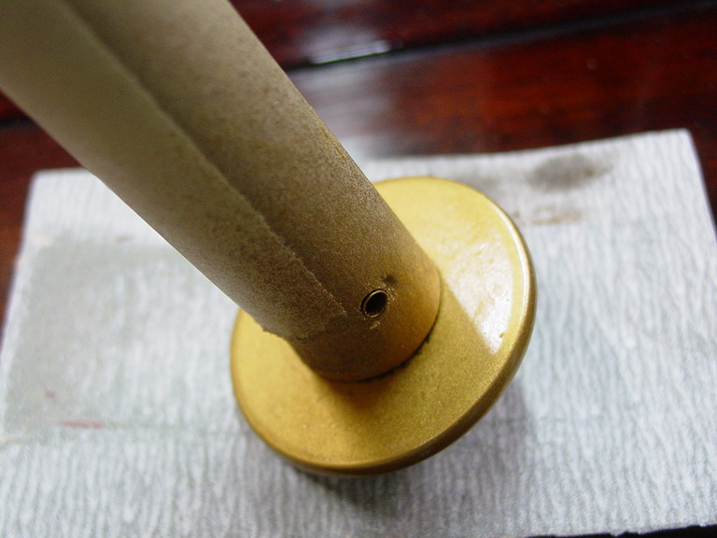
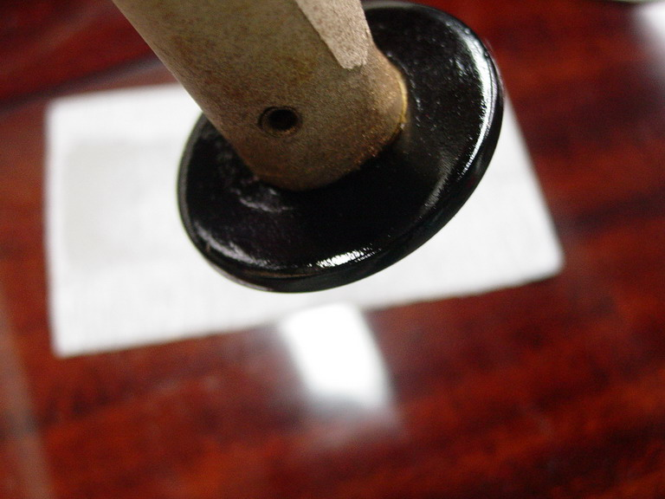
Sand off the rust
Prime with metallic paint
Paint it after the primer’s dry

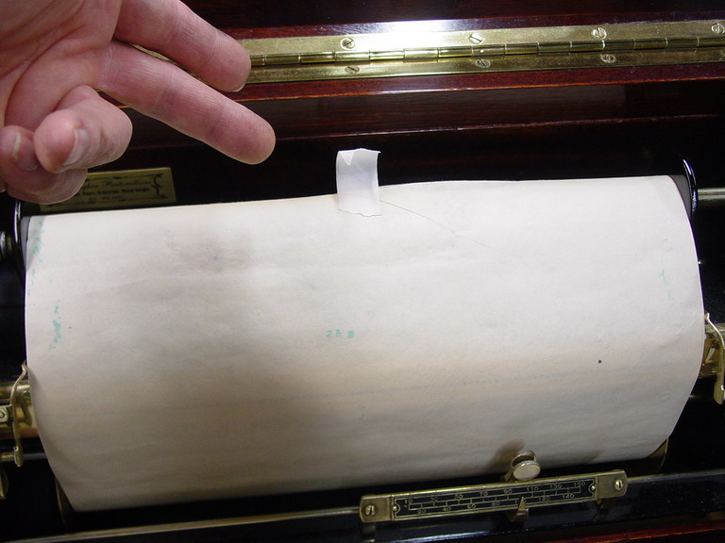
Getting the roll back together is really simple. Just chuck up the empty spool again and with a single piece of tape at about the center of the roll paper, stick it back on the spool and roll by hand of a couple turns, then turn the piano on and let it reroll it back. This procedure can be easily done if, when you’re at the hardware store you buy a can of black lacquer spray and a metallic lacquer spray, a razor knife, and some masking tape.
To paint the LEFT flange, you just pull it from the cardboard spool, of course.

Before you take the time to repair any torn roll or rusty flange, make sure the flanges don’t wobble as the roll turns. A wobbling flange will tear rolls whether it’s rusty or not. Likewise will a plastic roll flange. If you have to throw away old rolls, keep the spools and flanges if they’re good. You may need one sometime.

Some other notes about player rolls is that not all of them will play perfectly on every piano, including those designed for a specific reproducing format. For instance very early Duo-Arts, up through the transition models about 1918 will starve on a very few later Duo-Art arrangements cut in the 30’s. So in case you have a few late rolls like that, don’t worry. It wasn’t intended to play perfectly. So if you happen to have a roll like “Negro Heaven,” or “Goin’ To Heaven On A Mule,” and your early model can’t play all the notes-- well, the arranging format was changed to accommodate the new designs in the 30’s. There’s nothing necessarily wrong with your player.

Another thing you will also notice is that once in awhile a very soft note plays at its softest intensity in one place on the roll, and yet in the same roll later on, it misses. Why? That’s a coding error, and it usually has to do with a transitioning loud pedal. Don’t worry about it. They were close to perfect, but not always. And you’ll notice that some days your piano gets it and some days it doesn’t. It was too marginally coded. These were mechanical marvels and worked perfectly when coded perfectly.

